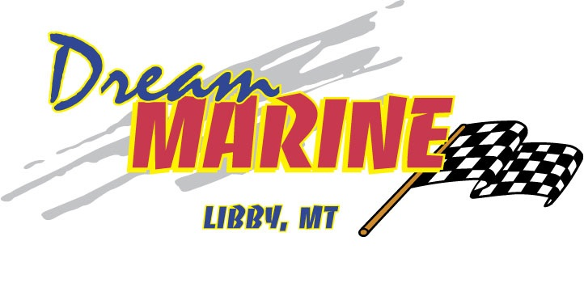
2023 DUCKWORTH 20 NAVIGATOR SPORT HT W/ HONDA 200HP
& HONDA 10HP

-PAINTED CABIN, HALF-SIDE & TRANSOM PAINT, BOW BOX, CABIN SIDE MOUNT ROD HOLDERS, FISHERMANS TRANSOM- FISH BOX W/ LIVEWELL, SWIM PLATFORM STANDARD- REMOTE TROLLING MOTOR- INCLUDES FUEL CONNECT, SWIM STEP & GRAV HANDLE & 3 STEP LADDER, STARBOARD + PORT WINDSHEILD WIPER, HYDRAULIC STEERING, UPGRADE FIXED PEDESTAL TO DELUXE CAPTAIN, UPGRADE TO 37” REAR BENCH SEATS W/ INSERTS.

