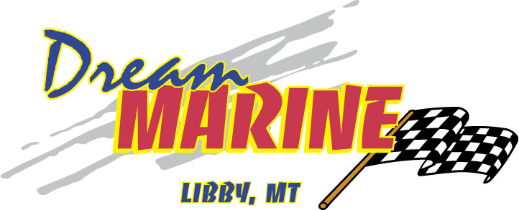

2022 HEWESCRAFT 190 SEA RUNNER

OPTIONS: DELUXE LONG CANVAS, SINGLE FUEL/WATER SEPARATOR, 3 LED COURTESY LIGHTS, REAR DECK FISHBOX, 6” BELLOWS WITH HIGH-BACK ON STBD & PORT SIDE, 37” JUMP SEAT, SKI-PYLON WITH UTILITY TRAY, BAYSTAR HYDRAULIC STEERING, STBD SWIM LADDER, 9” X 12” ELECTRIC TRIM TABS, WASHDOWN PUMP, & STANDARD WINDSHIELD.

2022 EZ LOADER 102BT 19-22 4700# WITH TRANSOM TIE DOWN, SPARE TIRE & WHEEL, TIRE CARRIER, HYDRAULIC DISC BRAKE, & 9’ BUNK LOAD GUIDE.

2022 HONDA 150HP OUTBOARD

