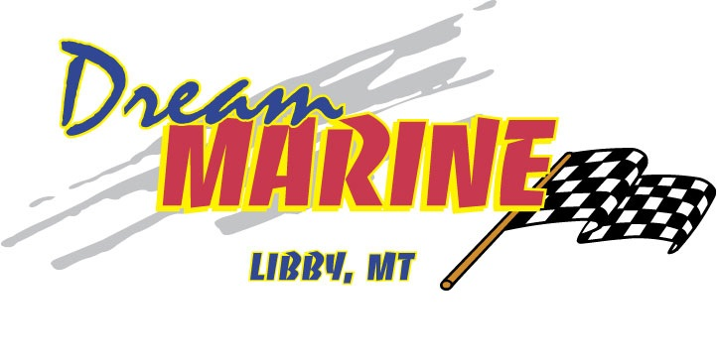
2023 DUCKWORTH 18 ADVANTAGE SPORT W/ HONDA OUTBOARD 100HP & EZ LOADER TRAILER

-DROP IN BOW BOX, 1/4 SWIM PLATFORM W/3 STEP LADDER, BOW LIVEWELL, STARBOARD + PORT WINDSHEILD WIPER, FLOOR CURTESY LIGHTS, 26” REAR STORAGE SEATS W/ SIDE CURTAINS & BACK DROP, CONVERTIBLE TOP BOOT, WASHDOWN PUMP SYSTEM

